0，90，90->[16.7,0,-9.7]forward

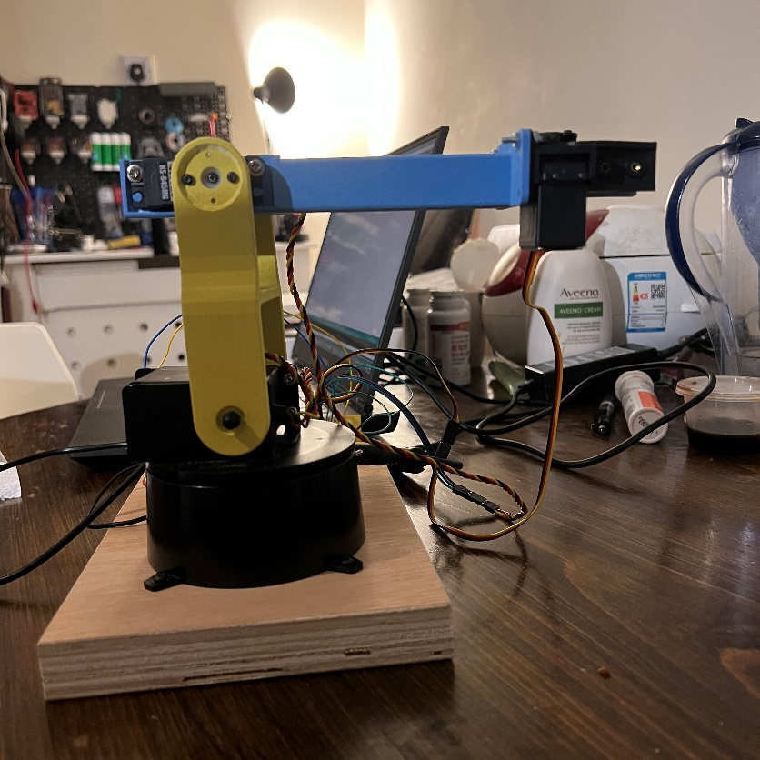

45,120,150->[6.7972,6.7972,-0.0504]

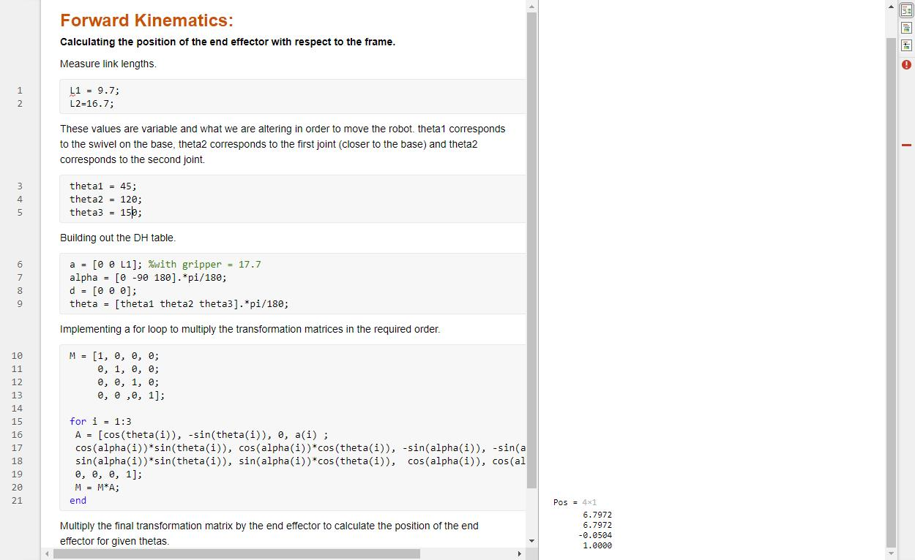

30,75,20->[10.4696,6.0446,-23.0493]

100,30,55->[-4.0869,23.1782,2.2077]

140,60,10->[-11.9385, 10.0176,- 21.1934]

